From: <http://thefederalist.com/2016/02/09/the-donald-trumpets-a-populist-language-that-goes-back-to-1776/>

[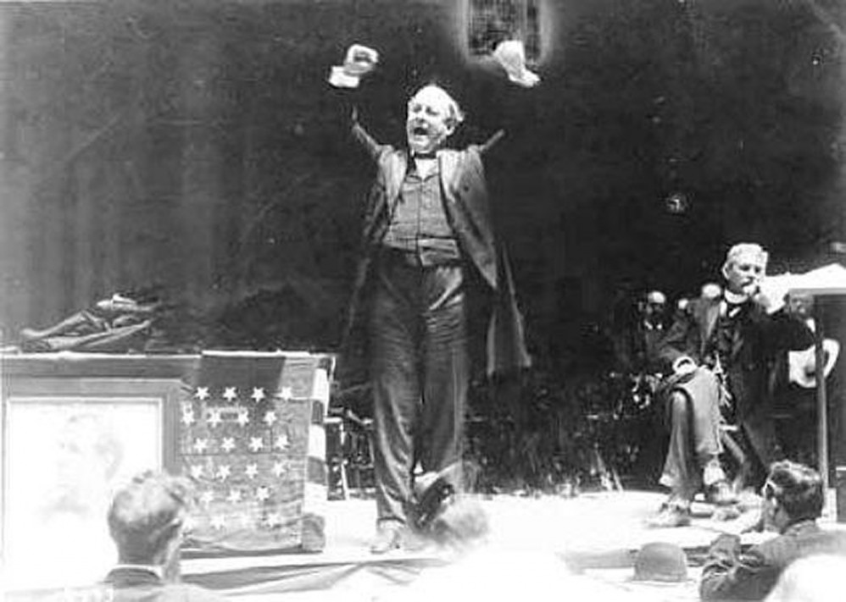](http://thefederalist.com/2016/02/09/the-donald-trumpets-a-populist-language-that-goes-back-to-1776/)

* [HISTORY](http://thefederalist.com/category/culture/history/)

[The Donald Trumpets A Populist Language That Goes Back To 1776](http://thefederalist.com/2016/02/09/the-donald-trumpets-a-populist-language-that-goes-back-to-1776/)

*America has a long political tradition of candidates violating entrenched elites and nearly every political piety of the day by daring to say what the people really feel.*



By [Scott Rank](http://thefederalist.com/author/scottrank/)

FEBRUARY 9, 2016

Donald Trump loves violating the conventional rules of politics. His boycott of the GOP debate four days before the Iowa caucuses is only the most recent. He has insulted a war hero for having ended up in a prisoner of war camp, proposed banning adherents of an entire religion from entering the United States, and has a comb-over that violates the conventional rules of physics.

Trump might be unconventional, but he is not unprecedented. He is part of a populist strain in American politics that includes senators, governors, and at least one president. This strain includes 1940 GOP presidential candidate Wendell Wilkie, a businessman with no political experience, and Depression-era Louisiana Gov. Huey Long, a media-savvy radio personality who called for government to seize and redistribute all private assets over $1 million. It includes nineteenth-century populists such as William Jennings Bryan and Andrew Jackson.

These populists are not united by a coherent ideology. There isn’t a set of ideas that links the 1890s anti-capitalist People’s Party to a Trump rally in 2016. Rather, they are united by a common language.

Georgetown University history professor Michael Kazin wrote in his 1995 book “The Populist Persuasion” that populism is a language of the dispirited, spoken to agrarians and artisans.

It is

1. a form of rhetoric,
2. a “flexible mode of persuasion.”

Populists speak of hardworking, self-reliant producers threatened by a parasitic elite.

It is up to them to help producers rise up against them to restore America.

Populists us an “us versus them” language. They lionize merchants, farmers, or anyone else who produces something useful for society. They demonize speculators, financers, gamblers, lawyers, or anyone who does not or will not work for a living.

The elites may change—Bryan rallied against wealthy financers for trapping farmers into debt; Trump rallies against “losers” in Washington who can’t enforce federal immigration laws—but the language remains the same.

Populism in America’s Early Decades

The Founding Fathers spoke the populist tongue when it suited them. Thomas Jefferson and John Adams waged America’s first dirty presidential campaigns in 1796 and 1800. Jefferson’s hatchet men told the media Adams had a hideous hermaphroditical character “which has neither the force and firmness of a man, nor the gentleness and sensibility of a woman.” Adams’ campaign retaliated, calling Jefferson a warmonger who wanted to trigger conflicts with America’s enemies, leading to a national orgy of “rape, incest, and adultery.”

Nasty politics aside, Adams and Jefferson may have used populist language to win presidential elections, but they were not populists themselves. Both were classically educated, reading Greek, Latin, and French fluently. The other first four presidents were of similar stock.

It was Andrew Jackson who broke with this aristocratic tradition. He was the first president born into poverty and raised in a log cabin. Throughout his life he believed the earth was flat. Most of all, Jackson had a bluntness of speech that was absolutely Trumpian.

“You are a den of vipers and thieves. I intend to rout you out, and by the eternal God, I will rout you out!” Jackson said to a delegation of bankers in 1832. He fought the recharter of the Second Bank of the United States. The bank provided loans, printed currency, collected taxes, and circulated money around the United States. But it was majority-owned by directors and stockholders unanswerable to the electorate. He thought it was a financial cabal that gambled the savings of poor farmers, craftsmen, and laborers on risky speculation.

Jackson promised to crush the bank. He thought it to be a hideous institution that funneled money from producers to parasites. “The bank, Mr. Van Buren, is trying to kill me,” he said to the future president, “but I will kill it.”

Jackson created the dictionary for American political populism.

Jackson created the dictionary for American political populism. He is the founder of Jacksonianism, a political tradition of candidates violating entrenched elites and nearly every political piety of the day by daring to say what the people really feel. The Jacksonian hero, writes historian Walter Russell Mead, “may make mistakes, but he will command the unswerving loyalty of Jacksonian America so long as his heart is perceived to be in the right place.”

The dark side of Jacksonianism is drawing a brutal distinction between members of the community and outsiders. Jackson supported the 1830 the Indian Removal Act, in which tens of thousands of American Indians were resettled west of the Mississippi at bayonet-point. Speaking as a former major general of the Tennessee militia, who saw settlers killed in Indian attacks, he described them as dangerous predators: “That those tribes cannot exist surrounded by our settlements and in continual contact with our citizens is certain. They have neither the intelligence, the industry, the moral habits, nor the desire of improvement.”

Then There’s William Jennings Bryan

Jackson formalized the American populist language, but William Jennings Bryan perfected its usage. Bryan was dubbed “The Great Commoner” for his faith in the wisdom of the common people over the educated elites. The nineteenth-century politician, thrice the Democratic Party’s presidential candidate, is considered by historians to be the first celebrity candidate in America, better known for his personality and catch phrases than his ideas.

Bryan’s prairie populism drew a distinction between rich and poor America, making the 1896 election the first to have class warfare as its central issue.

For two decades Bryan was the dominant force of the populist wing of the Democratic Party. He fought to end the gold standard, which deflated America’s currency, making it impossible for farmers to pay off their debts. When Bryan arrived at the 1896 Democrat Party meeting in Chicago, he asked delegates, “Upon which side will the Democratic Party fight; upon the side of the idle holders of idle capital or upon the side of the struggling masses?”

He attracted crowds in a way that would make Trump jealous. Bryan gave over 600 speeches in 1896 alone to an estimated 5 million listeners, usually from the backs of railroad cars. For good or ill, Bryan turned the modern American presidential campaign into the marathon race, cult-of-personality spectacle.

The media loved to caricature Bryan for his appeal to folk wisdom. Cartoonists drew him standing before crowds of yokels and hillbillies, literally blowing hot air over them. Critics thought he was a shameless panderer who built policy around his speeches, and not the other way around. Irving Stone, author of “They Also Ran,” said Bryan lacked the intelligence to be a good president. While this is an unfair criticism, Bryan’s plans lacked depth. He never bothered with consulting policy experts, deriding them as the “aristocracy of learning.”

Bryan’s prairie populism drew a distinction between rich and poor America, making the 1896 election the first to have class warfare as its central issue. Although he is a progressive hero, Bryan loved to speak in evangelical populist language. He considered America’s monetary policy to be a cosmic injustice, with poor farmers every bit as persecuted and every bit as innocent as Christ on the cross.

Bryan famously distilled this sentiment in his Golden Cross Speech: “If they dare to come out in the open field and defend the gold standard as a good thing, we shall fight them to the uttermost, having behind us the producing masses of the nation and the world….You shall not crucify mankind upon a cross of gold!”

Donald Trump’s Populist Parseltongue

How does Trump use the populist language of Jackson and Bryan? He lionizes self-reliant producers and calls out parasitic “losers,” whether political opponents or illegal immigrants from Mexico. Trump shouts from the podium that our leaders are morons.

At the same time, he lets his policy trail behind his sound bytes. He says British-style, single-payer socialized medicine would be good for us (an anathema position among Republicans) but only if somebody smart like him ran it. He has no problem with the monster that the federal government has become. If he runs it, Trump promises, then the beast can be tamed.

But mostly he lurches from insult to insult with little regard to consistency. A *New York Times* analysis of his speeches found that Trump tends to attack a person—usually as “stupid,” “horrible,” or “weak”—instead of an idea or situation. Since he’s a populist, it does not matter. He has an emotional connection with his audience, not a rational one. This was what Huey Long biographer Richard D. White calls “a purely personal relationship with his listeners. It is not based on factual issues.”

Trump speaks the language of populism fluently—just as well as Jackson and Bryan. If he didn’t, then he wouldn’t be the GOP front-runner. This is because he can’t speak any other language. [But how about this, from: <https://www.informationliberation.com/?id=55358> ? -FNC]

*Scott Rank is a postdoctoral fellow at Istanbul Sehir University's department of history. He has created an online course called “*[*American History and Donald Trump: The 200-Year-Old Roots of the Trump Campaign*](https://www.udemy.com/donald-trump-american-history/?couponCode=yuge)*.”*

Photo [Pubic Domain](http://www.realclearpolitics.com/lists/Convention_Moments/)